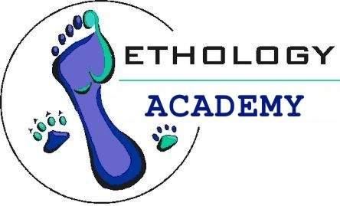P.O. Box 196 Tel: 012 654 3448/0725758586
Raslouw Fax: 012 654 7659
0109
E-mail: j.odendaal@ethology.co.za & hanna@ethology.co.za

Dear Prospective Student,

Thank you very much for enquiring about the Basic Behaviour Course: Horses

The study material for the Basic Behaviour Course: Horses was compiled by the late Prof. Johannes Odendaal. Ms. Altha Viljoen presents the Basic Behaviour Course: Horses on behalf of Ethology Academy.

The Basic Animal Behaviour Course: Horses is essentially done by correspondence with the optional attendance of a two-day seminar. Most of our students work full-time and the course is designed to be done part- time. We are a private company and very flexible. As long as students communicate with us we are usually able to accommodate them in various ways.

It consists of four modules.

- Introduction and approaches to the study of animal behaviour
- Problem behaviour and possible resolutions
- Applied Horse behaviour – normal and problem behaviour
- Care and welfare of Horses

After enrolling the student receives all the study material via registered mail. Included will be Student Letter giving detailed information on every aspect of the course. Also included will be the eight assignments (two on every module) each with an addressed envelope to make submitting them as convenient as possible. The marks obtained for the 8 assignments constitute the year mark and all must be submitted to gain entrance to the exam in November. The exam is a two-hour paper and the pass mark 50%. The assignments are not difficult because all the answers are in the notes. It should not take more than 2 – 3 hours to complete an assignment. The exam, scheduled for November, is a different kettle of fish and requires a fair amount of studying and insight. Students are therefore advised to start well in advance preparing for the exam.

NB: In addition to the content of the study material, we recommend purchasing a book on different horse breeds as the study material does not include information on specific breeds. Make sure to buy one that pays attention to the typical temperament of the breed.

Students are also invited to attend a two-day seminar. Horse seminars are hosted in Pretoria, Cape Town, and Port Elizabeth. The Cape Town and PE seminars will only be hosted if at least 5 students indicate that they would like to attend. Attendance of a seminar is not compulsory but highly recommended.

Enrolment takes place from 7Jan - 28 Feb. The enrolment fee for the Basic Behaviour courses for 2009 is R5, 000.
This fee includes the study material, attendance of the seminar (excluding travel and accommodation expenditures) and the examination fee.

How to enrol for this course:

- Click on ‘Enroll’
- Read ‘Terms of Engagement’
- Complete and submit the enrolment form
- Pay the appropriate fee
- Provide Hanna with confirmation of payment.

Do not hesitate to get in touch should you need more information.
Hope to be hearing from you again soon.

Hanna Odendaal: Course Administrator

